- Design
  - Overview
This code is aiming to set a variable-size sliding puzzle map and let the player solve it. I divided it into four parts: set basic map information (size and key binding situation), build a valid map, movements of the map and the game-end test.
Players can enter the map size and bind their own favorable keys to move the map. At the same time, this program will count the number of moves and deliver it to the player in real time. After finishing the map, the player can select to restart a new map or quit the game.
  - Data Model
In this program, I used string and list to solve this problem. String is used in handling the key binding and validity check. List is used in setting the map and dealing with the moves.
  - Program Structure
I will describe the structure in three parts.
    - Game interface
To make this game not that boring and cold, I designed the interface by using ASCII Art to hold the related information.
    - Local functions
The second part is some local functions to satisfy requirements.
    - Main function
The main function part is used to call my local functions and do some repeat jobs.
  - Processing Logic
    - After reading the size of the map, the program will generate a random but valid sliding puzzle map. Then after each move, test the map’s status and give a continue running command or end command.
    - It can be derived from mathematics that there are only two conditions to ensure that the map is legal. First, the map size is odd and inversion number is even. Second, the map size is even and the sum of the inversion number and the difference between the initial and final zero lines is even. After knowing this, I can easily build a valid map using the sample() function in module ‘random’. And test the map to decide to start game or rebuild a valid map.
- Function Specification
  - game_menu()
    - Parameters: none
    - Output: game starting menu
    - Use: print a game starting menu
  - game_info()
    - Parameters: none
    - Output: game information page
    - Use: print a game information page
  - game_process()
    - Parameters: moves
    - Output: total player moves page with moves in it
    - Use: print a total player moves page
  - game_end()
    - Parameters: answer (of whether to restart)
    - Output: is_game_restart
    - Use: print a game ending and restart confirmation page
  - map_size()
    - Parameters: size, test_map
    - Output: a test_map list
    - Use: set map size and create a ordered test map
  - map_keys()
    - Parameters: four-direction keys, keys, keys_no_space
    - Output: none
    - Use: bind keys and verify validity
  - map_self()
    - Parameters: map, zero_position, is_game_start, map_size, moves, inversion_num
    - Output: is_game_start, map_size, size
    - Use: compare test_map and map, verify whether valid
  - map_start()
    - Parameters: zero_position, is_game_end, moves
    - Output: is_game_end, move
    - Use: build and start the map, find zero position and test whether the game ends
  - map_move()
    - Parameters: four-direction is_keys, is_move, zero_position_x, zero_position_y, moveable
    - Output: is_move
    - Use: deal with the moves

- Output
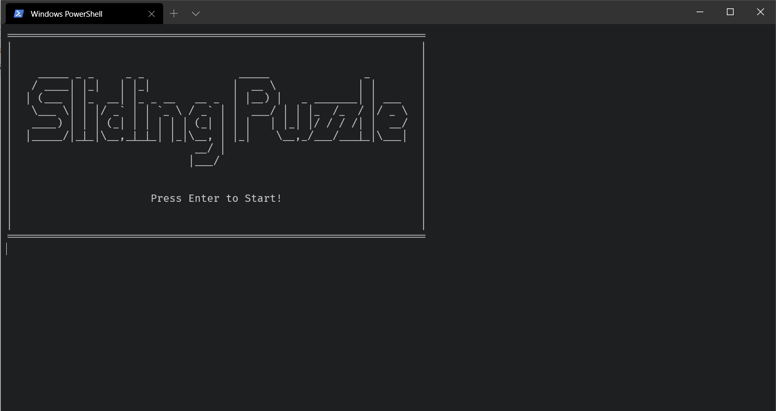
  - Start menu

  - Game info
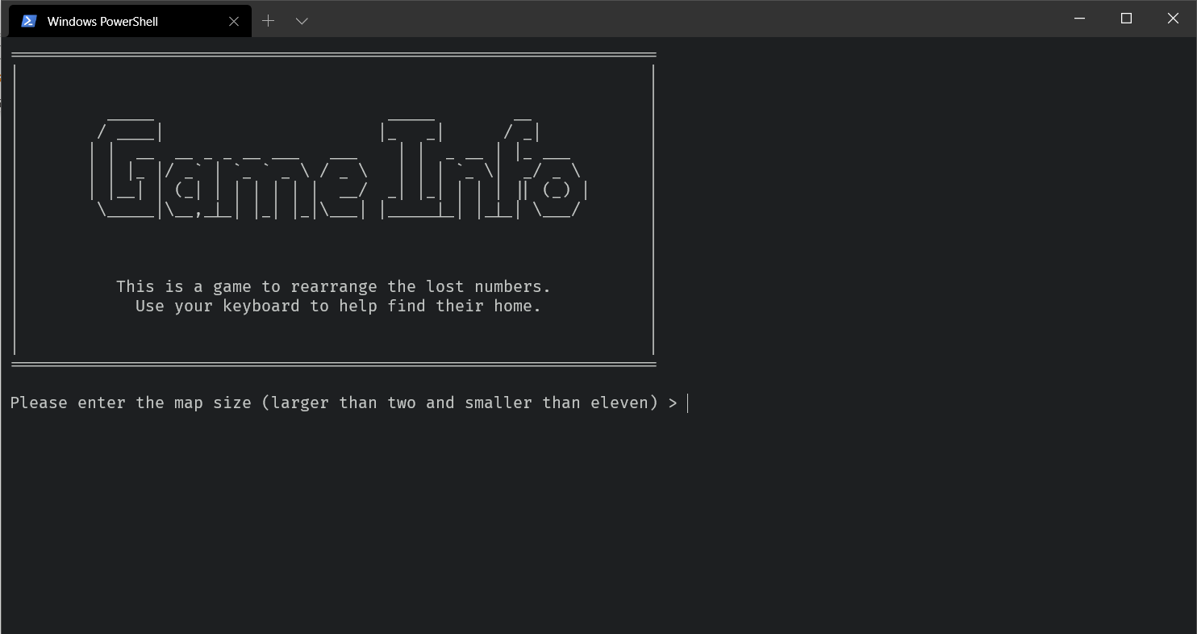

  - Map size & key binding
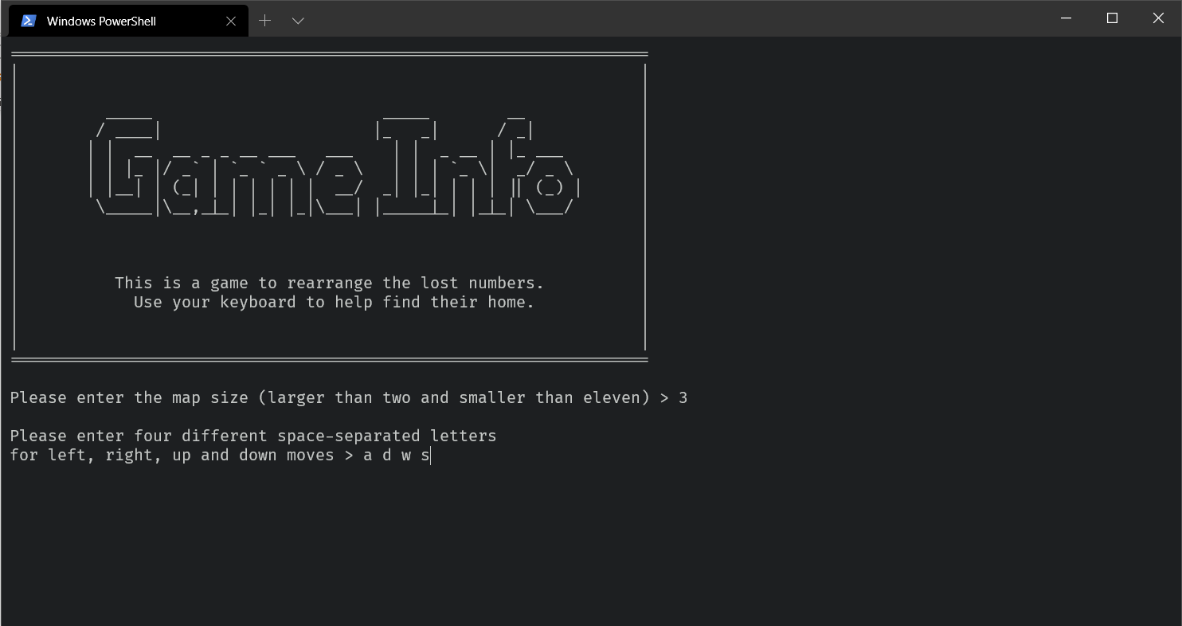

  - 3 * 3 map
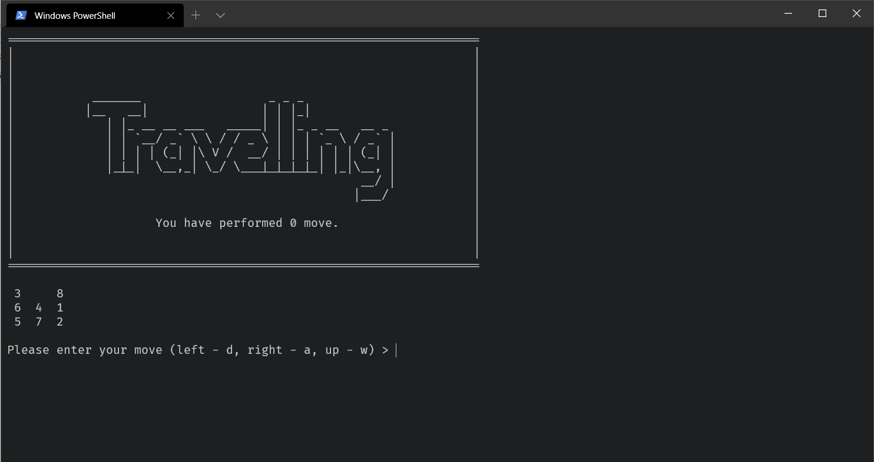

  - Wrong move prompt
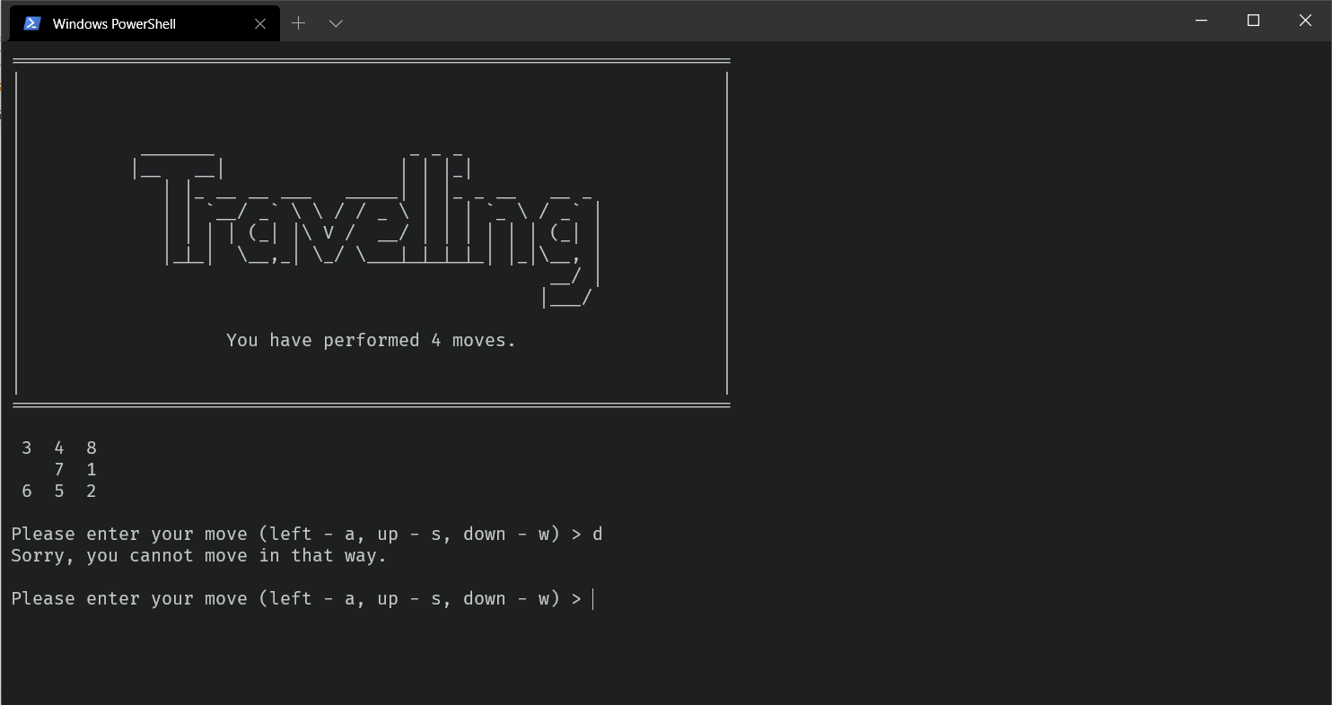

  - Total move (25 moves) and restart (y)
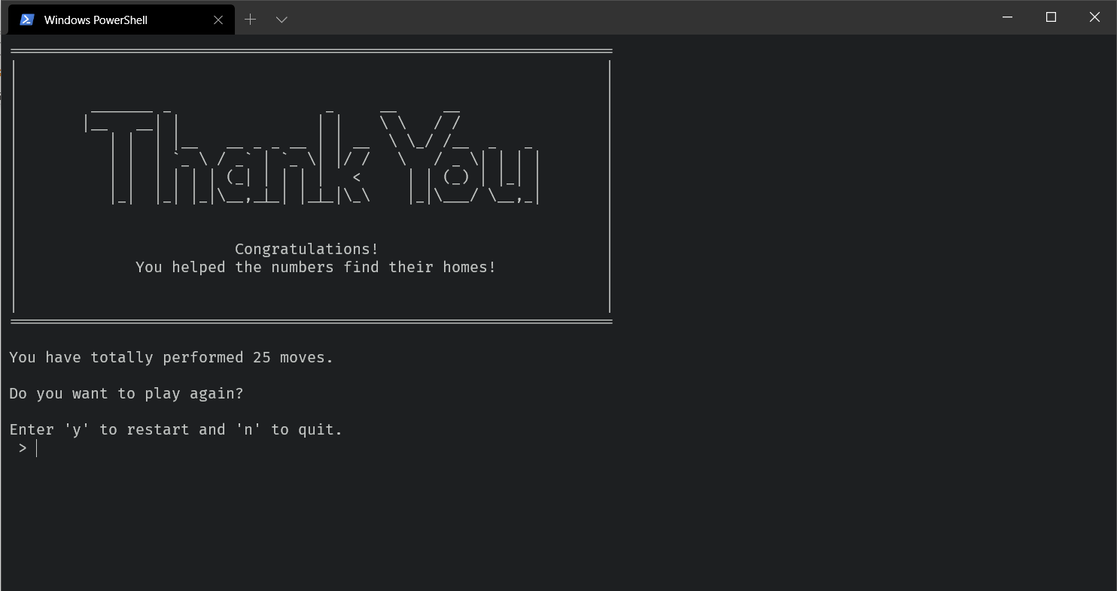

  - New 4 * 4 map
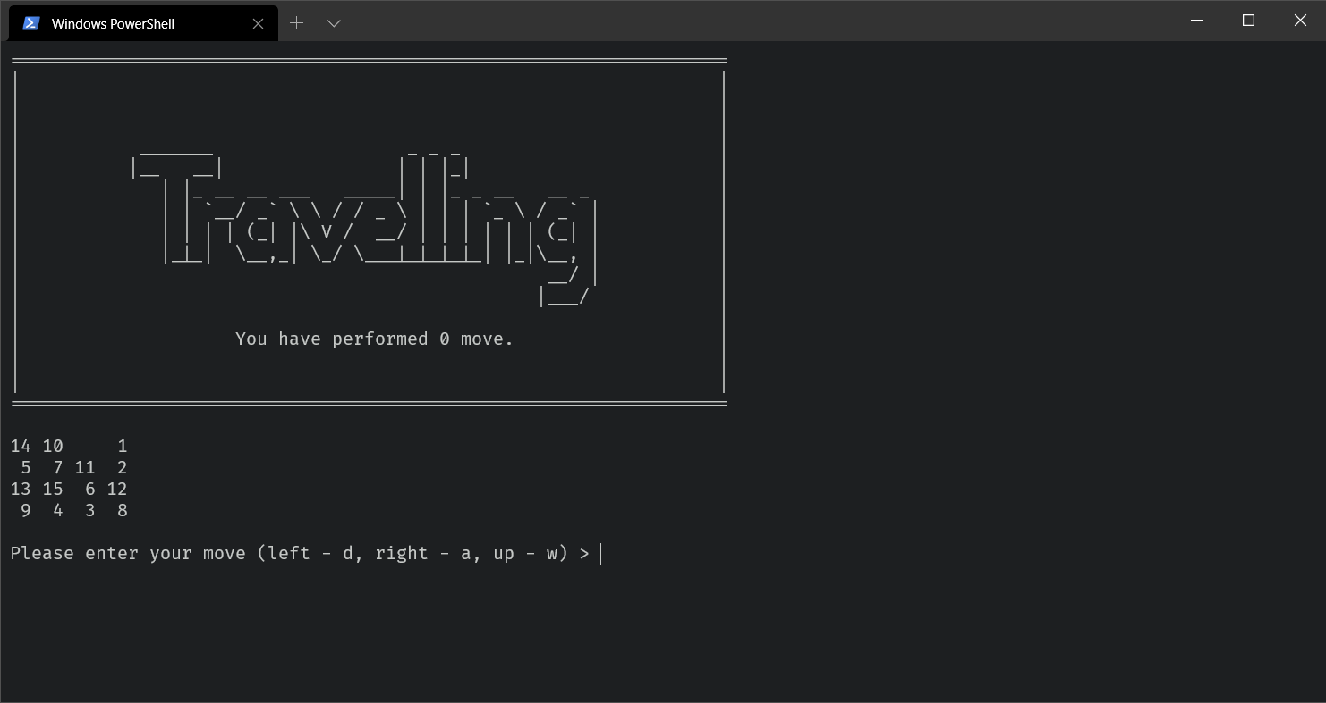

  - Minimum moves for this map (48 moves)
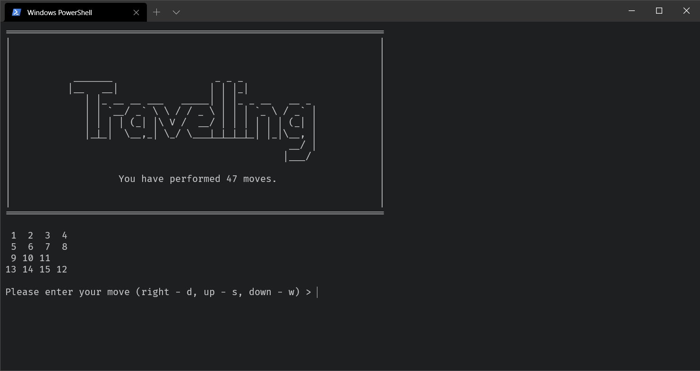

  - Game end (n)
